The figure below models which equation?

**1**.



A 6  2 = 36

B 66 = 36

C 62 = 36

D 4  9 = 36

The square root of 9 is 3. Which figure models this statement   
 = 3?

**3**.



A

B

**2**.

C

D

The model below represents

**4**.

 = 7.

Which arrangements of small squares can be used to model a large square that represents ?

A 2 rows of 50 squares

B 10 rows of 10 squares

C 4 rows of 25 squares

D 50 rows of 50 squares

Which model does NOT represent 32 ?

3

**5**.

**6**



A B

C D

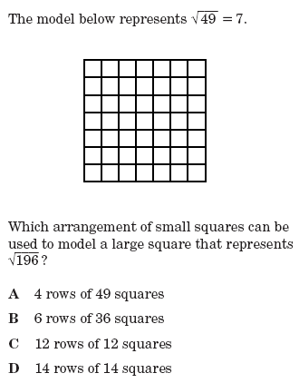

**7**



**8**.



$√100$?

A 4 rows of 25

B 11 rows of 11

C 2 rows of 50

D 10 rows of 10