For #1, 2, and 3, find the expression (rule) that can be used to find the value of any term in each sequence below where *n* represents the position of the term.

|  |  |
| --- | --- |
| Position, *n* | Value of Term |
| 1 | 5 |
| 2 | 9 |
| 3 | 13 |
| 4 | 17 |
| 5 | 21 |
| *n* |  |

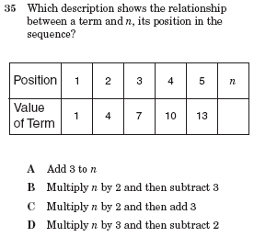

3.



1.

2.

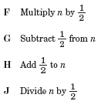

4.

5.

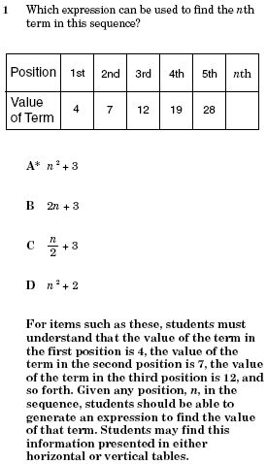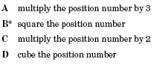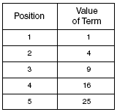

6.

7.

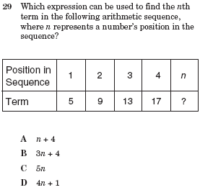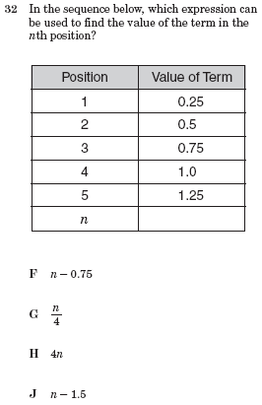

9.

8.

10.

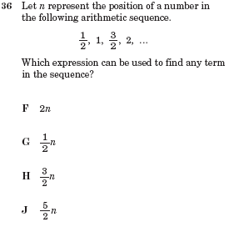

11.

12.

13.