The Real Number System Ex. A

Classify each number by determining all sets of numbers to which it belongs. Then write each number in the Venn diagram below.
1. 19 2. –6 3. 0

4. $\frac{\text{8}}{\text{4}}$ 5. 0.1$\overline{\text{6} }$ 6. π
Real Numbers
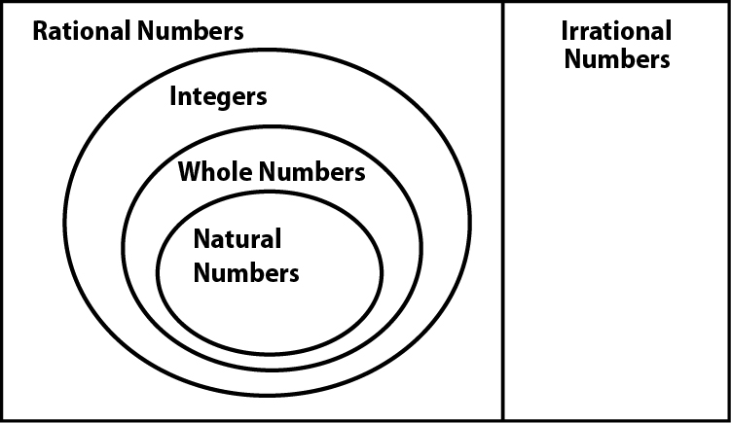

Exercises
Replace each with <, >, or = to make a true sentence. Use a number line if necessary.
1. $\frac{1}{2}$ $\frac{3}{8}$ 2. $\frac{4}{5}$ $\frac{8}{10}$

3. $\frac{3}{4}$ $\frac{7}{8}$ 4. $\frac{1}{2}$ $\frac{5}{9}$

5. $\frac{9}{14}$ $\frac{3}{7}$ 6. $-\frac{5}{7}$ $-\frac{6}{11}$

7. $-3\frac{1}{3}$ $-3\frac{2}{6}$ 8. $4\frac{9}{10}$ $4\frac{3}{5}$

