Card Station
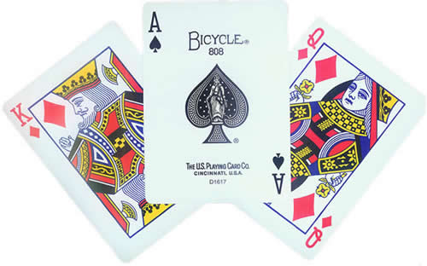

Using a standard deck of playing cards, what is the probability each of the drawing 1 card and getting: (Simplify fractions if possible.)
HINT

26 x 2 = 52

13 x 4 = 52
- a Jack?
- a 9?
- an 8 of Clubs?
- a red King?
- a black 10?
- a King or an Ace?
- a Spade?
- a Heart?
- Odd Card (only the cards with numbers)
10.a “FACE” card (Jack, Queen, or King)

Coin Station
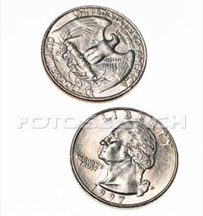

What is the probability of flipping a fair coin once and landing on:

- heads?
- tails?

What is the probability of flipping a fair coin twice and landing on:

- heads then tails?
- tails then tails?
- heads then heads?
- tails then heads?

What is the probability of flipping a fair coin three times and landing on:

- tails then tails then tails?
- heads then heads then heads?
- tails then heads then tails?
10.tails then heads then heads?

Color Cubes Station
R
B
O
R
G
Y
G
B
Y
B
B
R

What is the probability of drawing a:
B = Blue
G = Green
R = Red
O = Orange
Y = Yellow

- orange cube?
- blue cube?
- red or yellow cube?
- green or blue cube?

What is the probability of drawing once, replacing it, drawing a 2nd time and getting:

- orange cube then an orange cube?
- blue cube then a green cube?
- red cube then a red cube?

What is the probability of drawing once, NOT replacing it, drawing a 2nd time and getting:

- orange cube then an orange cube?
- blue cube then a green cube?
10.red cube then a red cube?

Fair Number Cube Station
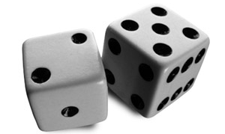

What is the probability of rolling one fair number cube and getting:

- a 2?
- an odd number?
- a 7?
- a number that is at least a 5?
- a number less than 4?
- a multiple of 3?

What is the probability of rolling two fair number cubes and getting:

- a double 5?
- a 2 and a 6?
- “snake eyes” (double one)?
10.one odd number and one even number?

Spinner Station

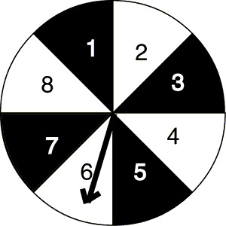

What is the probability of spinning the spinner shown above & landing on:

- a 5?
- an even number?
- a black space?
- a number less than 4?
- a number greater than 6?
- a prime number?
- a multiple of 3?
- a 4 then a 7?
- a multiple of 5 then a multiple of 4?
10.an even number then an odd number?

