1. What is the value of the expression:

17 + 3(11 – 4) – 5

2. A case of hot dogs weighs

7.84 pounds. Which of these

is a reasonable weight for

each hot dog if there are 36

hot dogs in the case?

3. The model below represents $\sqrt{49}$ = 7.

Which arrangements of small squares can be used to model a large square that represents $\sqrt{144}$?

A 6 rows of 24 squares

B 10 rows of 10 squares

C 12 rows of 12 squares

D 2 rows of 72 squares

4. Lillie’s grandmother is making potato salad for a family reunion. She uses three potatoes for each person attending the dinner. If she expects 32 people to attend the reunion, which proportion can be used to solve for *p*, the number of potatoes?

A = C =

B = D =

5. Caleb ate 3 big marshmallows in 30 seconds. At this rate, approximately how many minutes would it take Caleb to eat 20 marshmallows?

A 200 minutes

B 8 minutes

C 6 minutes

D 7 minutes

6. Ashlynn bought 4 equally- priced CD’s for $48. Caroline bought 7 CD’s that cost the same rate. How much did Caroline spend on her CD’s?

7. Look at this problem:

40 $-$ 6 x 5 + 20 ÷ 4

Which of these gives the correct order of operations for solving this problem?

A $-$, x, +, ÷

B ÷, x, $-$, +

C x, ÷, +, $-$

D x, ÷, $-$, +

NOW simplify the expression: ____

8. Mr. Franklin asked each of his 45 students to select their favorite radio station.

● $\frac{1}{3}$ of the students chose Station K.

● $\frac{1}{5}$ of the students chose Station L.

● The remaining students chose

Station M.

How many students chose EACH station as their favorite station?

K: _____ L: _____ M: _____

9. Determine if EACH statement

is TRUE or FALSE. If it is

FALSE, then give the correct

answer.

(1) $-2 ∙ -3 = -6$

(2) $5 ∙ -2 = 10$

(3)

(4)

(5)

(6)

(7)

(8)

10. Describe / name each set.

**Set J:**

**Set K:**

11. Coach Flores wants to get her brother a video game rental gift card for Christmas. There are four video stores in her neighborhood.



$55

$22

$36

$66

Find the unit cost of a game at EACH video store. Which store has the cheapest rental per game?

12. A 12-ounce jar of peanut butter costs $1.68. To the nearest cent, what is the cost per ounce?

13. Nick bought a package of 6

Hershey candy bars for $4.50.

Who else bought candy bars for

the SAME UNIT price PER

CANDY BAR?

A Jared bought a 3-pack of

candy bars for $2.55.

B Cameron bought a 2-pack of

candy bars for $1.70.

C Dillon bought a 5-pack of

candy bars for $3.65.

D Kristen bought a 4-pack of

candy bars for $3.00.

14. Which expression is represented by this model?

0

-

1

-

2

-

3

1

2

3

A 3 ● -1 = -3

B 3 ● 2 = 6

C 3 ● -2 = -6

D -3 + -2 = -6

15. The figure below models which equation?



A 8 ● 2 = 64

B 82 = 64

C 86 = 64

D 84 = 32

16. Simplify the expression.

(2 + 8)2 ÷ 4 – 2 ● 8

17. SQR is similar to $∆$ SPT.



Which segment corresponds to PS?_____ QR? _____ SR?_____

18. A model of a sailboat is 9 inches high and 4 inches wide. If the actual sailboat is 36 feet high, what is the width?

19. Alyssa drew a map of her neighborhood. She used a scale in which 2 cm equals 5 miles. On the map, the distance between Alyssa’s house and the middle school is 8 cm. How many miles is it from Alyssa’s house to the middle school?

20. The two triangles below are

similar.



Which proportion could be used to find p?

A

B

C

D

21. Every day the Pruneda family eats about $\frac{1}{2}$ box of cereal. At this rate, how many boxes of cereal does the Pruneda family need to buy to have enough cereal for 3 weeks?

A 21 B 11 C 10 D 8

22. Which equation can be used to find *y*, the number of hours in *x days*?

y

hours

x

days

A y=100x

B y= 24x

C y= 12x

D y=

23. Which statement is FALSE?

A

B

C

D

24. Look at the two pictures below; they are similar.



x

18 in.



Which proportion can be

used to find x?

A C

B D

25. Write 2 statements for each

model.







26. The prices of three different Monster drink cans are given

below.

12 oz. can 🡪 $1.80

16 oz. can 🡪 $2.40

20 oz. can 🡪 $3.20

Which Monster drink can has the lowest price per ounce?

A 12 oz can only

B 16 oz can only

C 20 oz can only

D Both the 12 oz & 16 oz cans

27. What measurement

relationship is shown by each

graph?

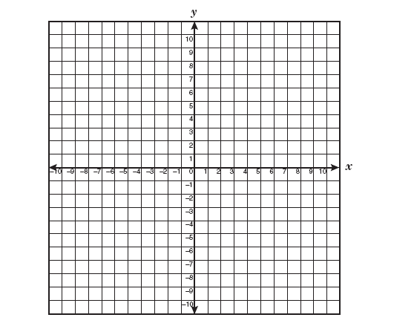

1

2

4

3

5

1

2

3

4

5

A feet to yards

B feet to inches

C cups to ounces

D days to hours

E pints to quarts

F quarts to gallons

15



1

2

4

3

5

5

10

25

20

29. Grid C #1. Mrs. Carrera bought a new recliner for her husband. The regular price of the recliner was $780; however, it was on sale for 30% off. What was the recliner’s sale price?



30. Grid C #2. Jazlynn’s senior ring cost $276 plus 8% sales tax. What was the total cost of Jazlynn’s senior ring?

