Unit Cost: Notes

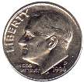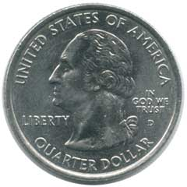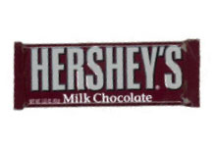

$2.10 for the package of 6 candy bars

Joseph paid for the 6-pack of Hershey candy bars with the change that he had in his pocket (shown below). Use the change to find the cost of EACH candy bar.

# candy bars

$

6

1

2.10

?

Unit Cost = the cost of 1 item

Unit Cost: Notes



$2.10 for the package of 6 candy bars

Joseph paid for the 6-pack of Hershey candy bars with the change that he had in his pocket (shown below). Use the change to find the cost of EACH candy bar.

# candy bars

$

6

1

2.10

?

Unit Cost = the cost of 1 item