1. Part I: Write down in words the steps are needed to find the shaded area.

10 ft

22 ft

Part II: Find the shaded area.

1. Part I: Write down in words the steps are needed to find the shaded area?

6 ft

13 ft

6 ft

Part II: Find the shaded area.

1. Mr. Flores bought a square spirit banner that has a wildcat inside the circle, shown below.

21 ft

6 ft

Find the shaded area.

1. Julissa’s room is shaped like the pentagon shown below.

16ft

9ft

12 ft

15 ft

16 ft

Julissa is getting new carpet. What is the area of her room?

1. Mrs. Morris has an aquarium, as shown below.

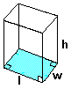

L = 20 in.

w = 15 in.

h = 30 in.

What is the area of the base?

1. Refer to problem #5. What is the volume of the aquarium?
2. Coach Kirkpatrick built a cube-shaped toy box for his daughter, as shown below.

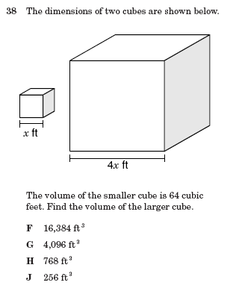

3 ft

What is the area of the base?

1. Refer to problem #7. What is the volume of the toy box?
2. Mrs. Lafayette made a giant cake, shown below, for her grandson’s birthday party.

20 in.



30 in.

What is the approximate area of the base?

1. Refer to problem #9. What is the approximate volume of the cake?
2. Mrs. Carrera had a huge aquarium, shown below, installed in her family room.

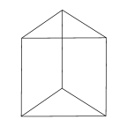

9 ft

4 ft

10 ft

What is the area of the base?

1. Refer to problem #11. What is the volume of the aquarium?

1. Mrs. Johnson bought a triangular prism bag, shown below, for her make-up.



8

12 in.

What is the area of the base?

1. Refer to problem #13. What is the volume of the bag?
2. Mrs. Brotherton bought her daughter a doll that was packaged in the box shown below.

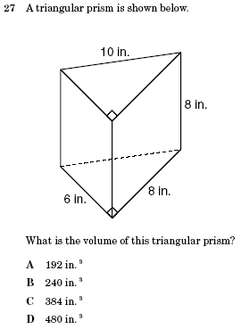

**7 in.**

4 in.

3 in.

6 in.

5 in.

What is the area of the base?

1. Refer to problem #15. What is the volume of the box?
2. Mrs. Monroe’s husband is building her a box out of plexi-glass, shown below, for an earthworm “farm”.



?

How tall should the box be if

Mrs. Monroe wants its volume to

equal 36,000 cm3?

1. Mrs. Garcia has 2 Tupperware containers, shown below.



10

8

A



3 in.

BX

Which container has the greatest

volume and what is its volume?

Container ____ has the greatest

volume with a volume of __________.

PreAP/GT Supplement

1. How much concrete would be needed to form the block below IF it did NOT have the two holes in it?



15 cm

30 cm

10 cm

1. How much concrete is needed to form the block in problem #15 WITH the two holes in it?