* Name the 3-D figure that the net represents and find the surface area of the 3-D figure.
* Find the area of each shape in the net and add these areas together.
* Make sure that you write down any formula that you use and neatly show your work.

1. Name: _________________________ Total Surface Area: ______________

(include correct label)

All squares

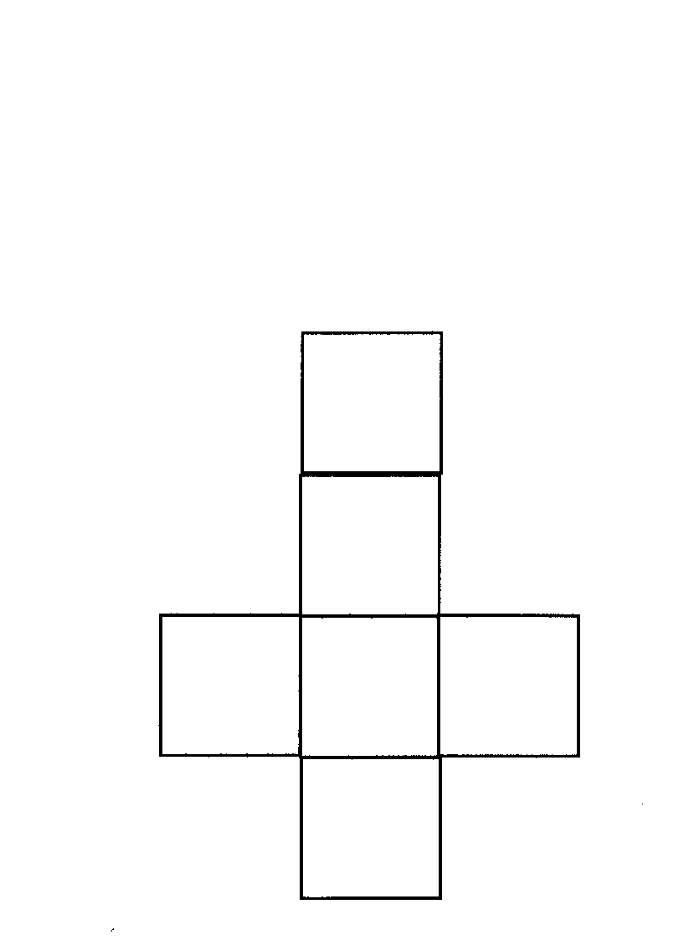

5 in.

2. Name: _________________________ Total Surface Area: ______________

(include correct label)

Consider the 2 squares the bases.

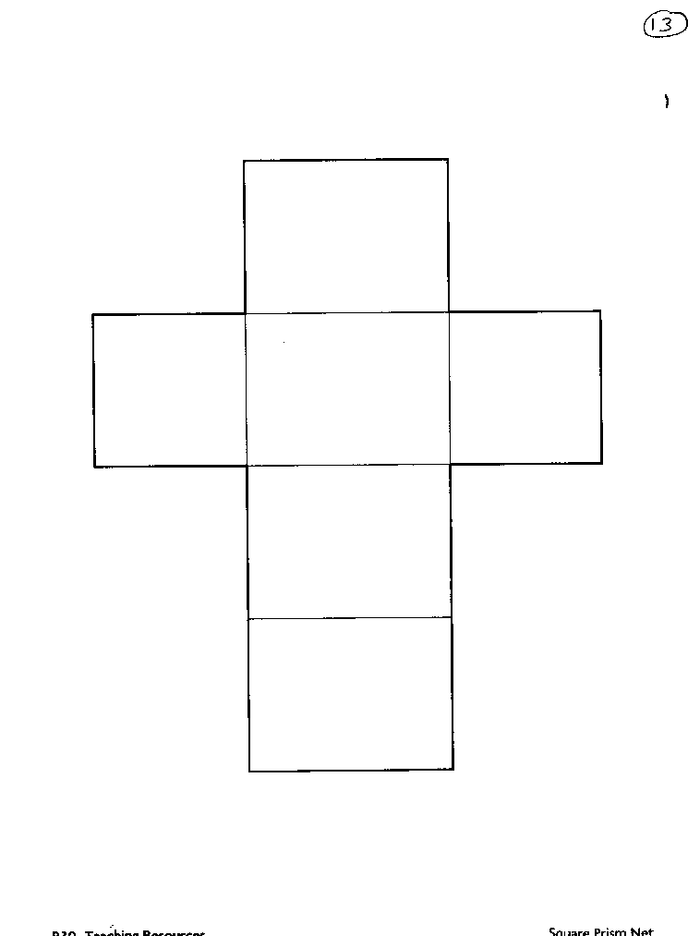

14 cm

11 cm

11 cm

3. Name: _________________________ Total Surface Area: ______________

(include correct label)

Bases are the 2 “flaps”

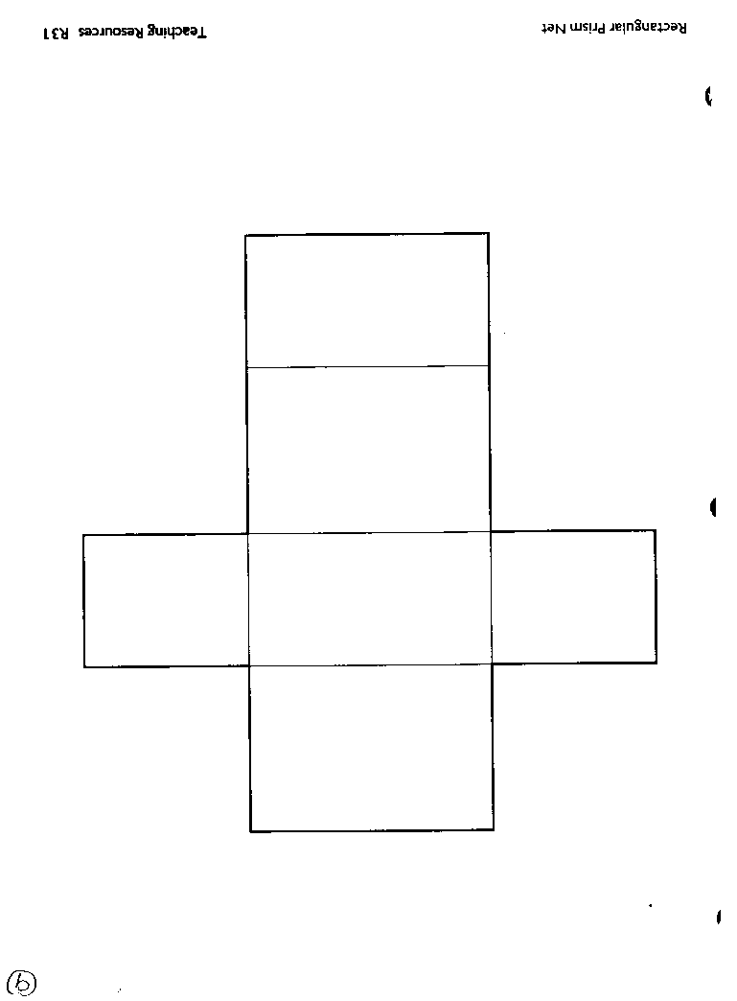

7 in.

8 in.

15 in.

4. Name: _________________________ Total Surface Area: ______________

(include correct label)

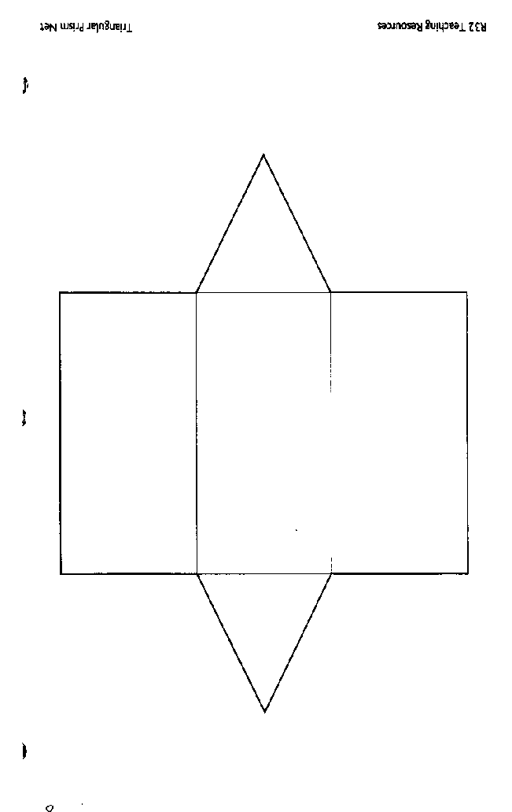

8 in.

8 in.

6 in.

6 in.

6 in.

25 in.

7 in.

5. Name: _________________________ Total Surface Area: ______________

(include correct label)

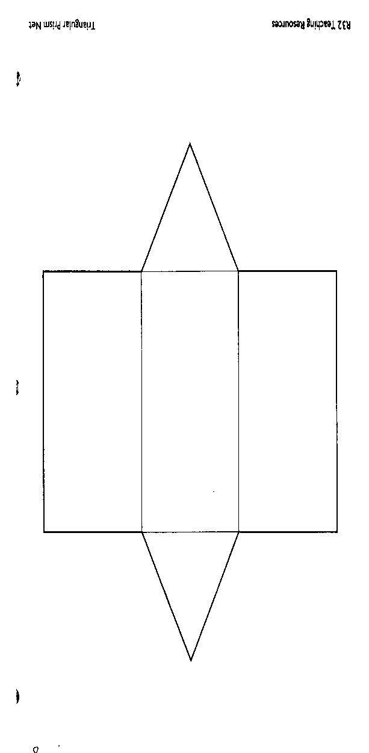

14 in.

13 in.

14 in.

14 in.

12 in.

14 in.

40 in.

6. Name: _________________________ Total Surface Area: ______________

(include correct label)

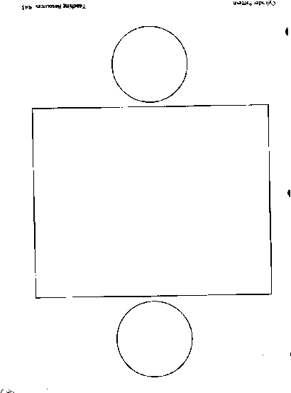

10 cm

46 cm

This # is the same as the CIRCUMFERENCE of the circle. Find C, use 3 for .

7. Name: _________________________ Total Surface Area: ______________

(include correct label)

24 ft

This # is the same as the CIRCUMFERENCE of the circle. Find C, use 3 for .

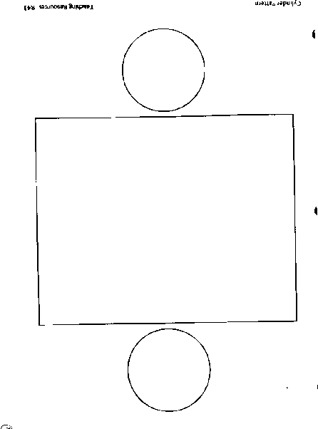

6 ft

8. Name: _________________________ Total Surface Area: ______________

All 4 equilateral triangles are congruent.

(include correct label)

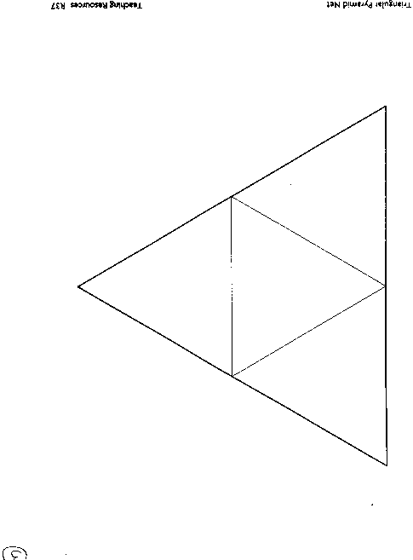

8 m

9 m

9. Name: _________________________ Total Surface Area: ______________

(include correct label)

The base is a rectangle.

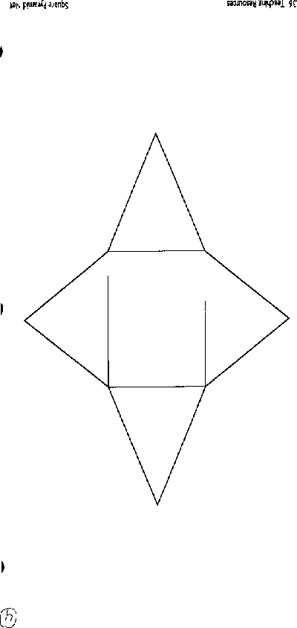

9 ft

10 ft

7 ft

8 ft