- Name the 3-D figure that the net represents and find the surface area of the 3-D figure.
- Find the area of each shape in the net and add these areas together.
- Make sure that you write down any formula that you use and neatly show your work.

1. Name: _________________________ Total Surface Area: ______________
(include correct label)
All squares
3 in.

Real world example:

2. Name: _________________________ Total Surface Area: ______________
(include correct label)
Consider the 2 squares the bases.

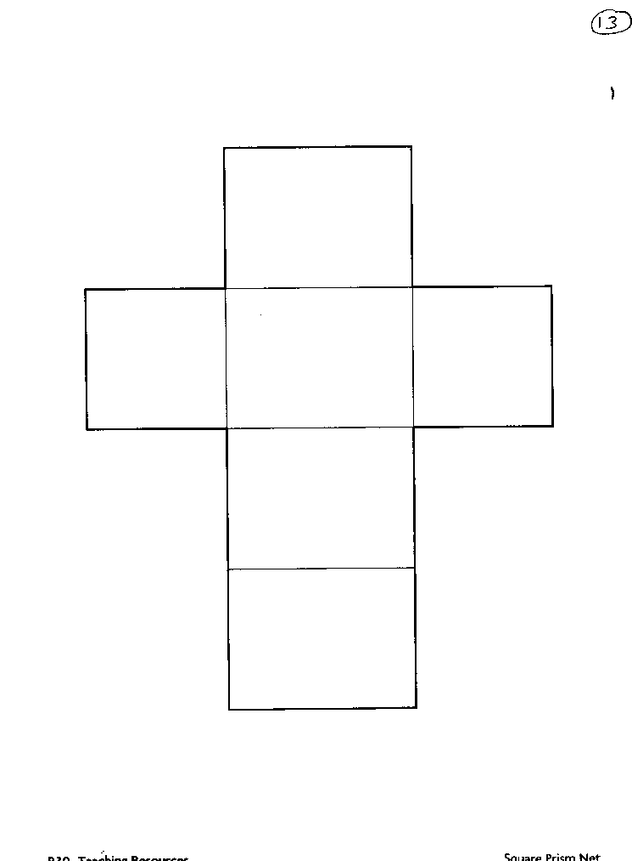
13 cm
10 cm
10 cm

Real world example:

12 in.
3. Name: _________________________ Total Surface Area: ______________
(include correct label)
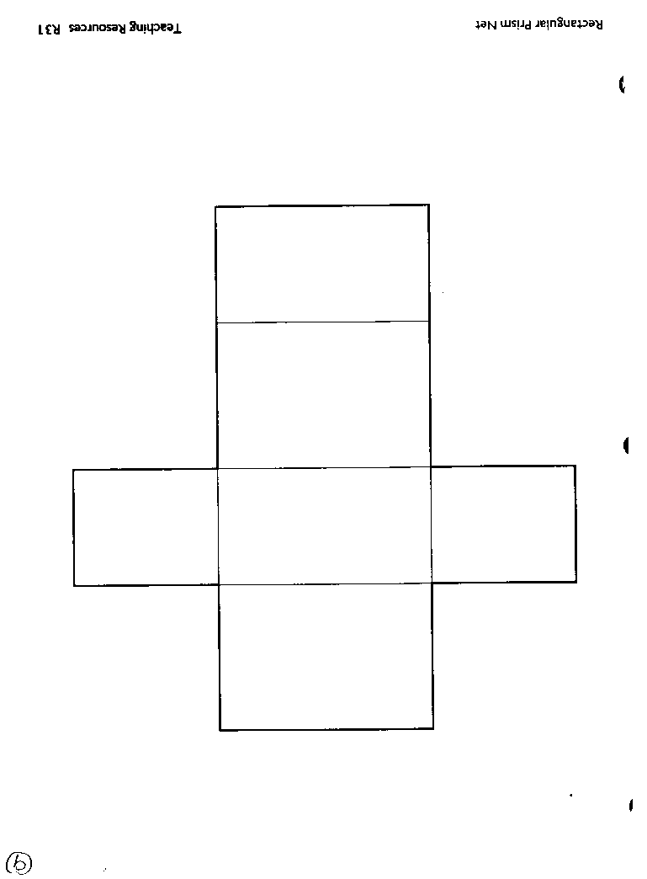
Bases are the 2 “flaps”
5 in.
6 in.
12 in.

Real world example:

4. Name: _________________________ Total Surface Area: ______________
(include correct label)
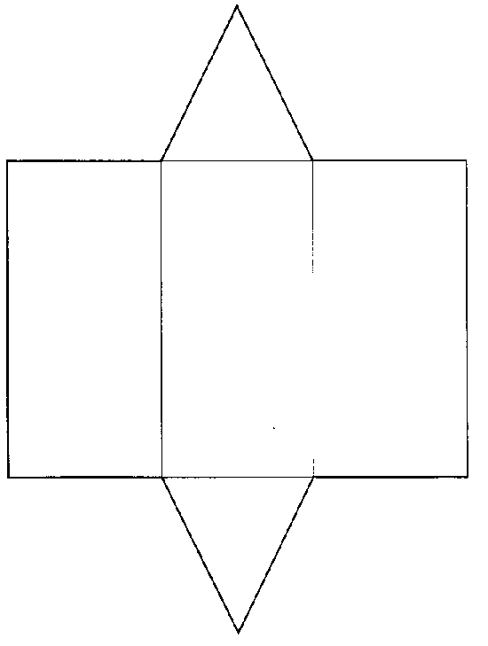
5 in.
5 in.
4 in.
5 in.
5 in.
22 in.

6 in.

Real world example:

5. Name: _________________________ Total Surface Area: ______________
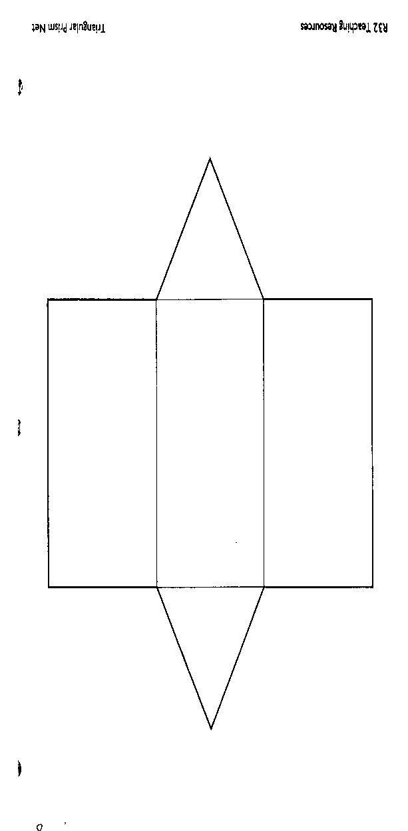
(include correct label)
13 in.
12 in.
13 in.
13 in.
10 in.
13 in.
30 in.

6. Name: _________________________ Total Surface Area: ______________
(include correct label)
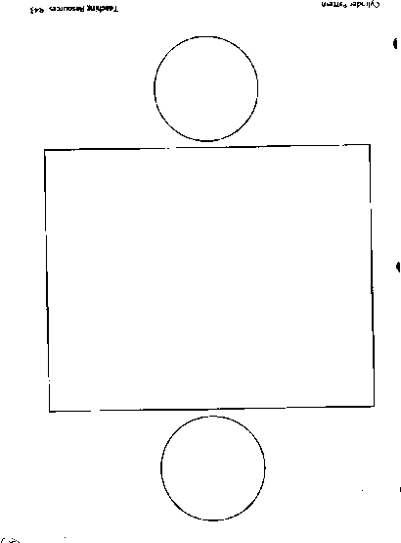
8 cm
40 cm
This # is the same as the CIRCUMFERENCE of the circle. Find C, use 3 for $π$.

Real world example:

7. Name: _________________________ Total Surface Area: ______________
(include correct label)
24 ft
This # is the same as the CIRCUMFERENCE of the circle. Find C, use 3 for $π$.

5 ft

Real world example:

8. Name: _________________________ Total Surface Area: ______________
All 4 equilateral triangles are congruent.
(include correct label)
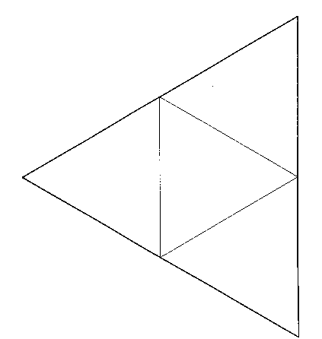
7 m
8 m
Real world example:

9. Name: _________________________ Total Surface Area: ______________
(include correct label)
The base is a rectangle.
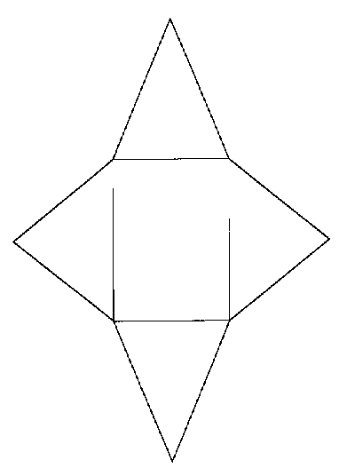
8 ft

9 ft
6 ft

7 ft

Real world example:

