Objective: Solve problems (probability of composite events & others such as combinations, arrangements, and predictions) using the strategy of systematically organizing data, including using *tree diagrams*, *lists*, *tables*, and *acting it out*.

1. Randy has a quarter, a dime, a nickel, and a penny. He tosses all four fair coins up in the air simultaneously. What is the probability that all four coins will land on tails?

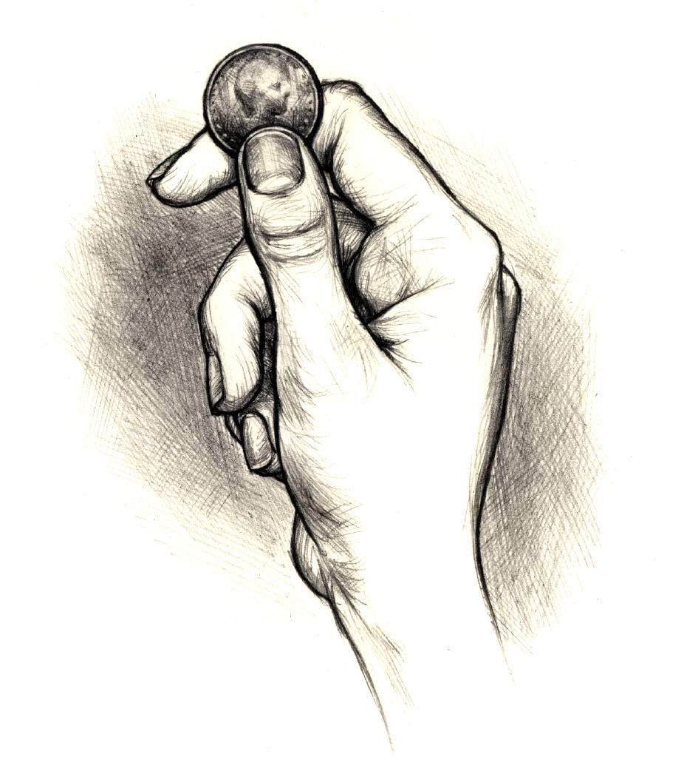

Answer:

✰ Draw a *tree diagram* to support your answer.

Quarter

Heads

Tails

1. Kristen uses the spinner shown below and a fair number cube in a game. Notice that the spinner has an equal chance of landing on one of five colors: red, blue, yellow, green, or orange. The faces on the number cube are labeled 1 through 6. What is the probability of Kristen spinning and getting the color blue and then rolling a prime number on the number cube?

✰ Draw a *tree diagram* to support your answer.

Answer:

 

Red d



Bed d



Oed d



G d



Yed d



1. Lindsay has a pair of dice; one die is red and the other one is green. The dice are “fair” number cubes labeled one through six on the faces. If Lindsay rolls the dice once, then what is the probability of Lindsay rolling a double four?



Answer:

✰ Make a partial tree diagram of the sample spaceto support your answer.

1. Look at the spinner below; Wendy is coloring this spinner for a game that her group created. Wendy has one section to color and can’t find the design plans for the spinner. Bobby reminds Wendy that the probability to land on one color is ½. What color should the region labeled with a question mark (?) be so that the probability of the pointer landing on this color is ½?



Color Abbreviations

B = Blue

G = Green

R = Red

Y = Yellow

Answer:

**R**

**?**

**B**

**G**

**G**

**GB**

**Y**

**B**

1. The probability of a person randomly selected being left-handed is about **.** Using this data, about how many people would be left-handed in a crowd of 4,978?



Estimate!

Left-handed

Total

10

1

Answer:

1. The results of a random survey show that 32 out of 60 students plan to vote for Josh for student council president, 20 out of 60 students plan to vote for Mindy, and 8 out of 60 have a write-in candidate for student council president. Based on this survey, which is the best prediction of the total number of votes that Josh will receive if 300 students vote in the election?

Total

Answer:



1. Principal Johnson determined that 75% of his students wore spirit shirts *at least* two days a week last year. If the school has 600 students, which statement does NOT represent Principal Johnson’s data?



Answer: _________ Why did you pick this answer?

* 1. 450 students wore spirit shirts at least 2 days a week last year
  2. 25% of the students never wore spirit shirts last year
  3. 150 students wore spirit shirts less than 2 days a week last year
  4.  of the students wore spirit shirts 2 or more day a week last year

“Scratch Work for #7”

Box C

Box B

Box A

1. What is the probability of randomly picking shapes and getting a quadrilateral from Box A and a non-polygon from Box C?
2. What is the probability of randomly picking shapes and getting a non-heart from Box B and a regular polygon from Box A?



1. What is the probability of drawing a polygon from Box C (with your eyes closed) and getting heads when you flip a fair coin once?
2. What is the probability of getting heads-heads-heads when you flip a fair coin three times?
3. What is the probability of getting tails when you flip a fair coin once and drawing a queen when you draw one card from a standard deck of cards?