Multiple Representations Exercise B

Activity 1 -- Disney World Trip

•Liz, Melissa, and Jen decided to drive to Disney World after college graduation. (Assume that they drove at a constant rate.) On the first day the girls got a late start, so they only drove 5 hours and traveled 300 miles.

•Find the unit rate for driving (speed) in terms of mph (miles per hour).

•Complete the chart, using the unit rate, graph the results, and answer the questions by the graph. ✰This time YOU must label the parts of the graph.

miles

hour

Find the unit rate for driving (mph 🡪 miles per hour).

x

y

|  |  |  |
| --- | --- | --- |
| # of hours, h | Mathematical Process | # of Miles, m |
| 0 |  |  |
| 1 |  |  |
| 2 |  |  |
| 3 |  |  |
| 5 |  | 300 |
| 6 |  |  |
| h | (description) | (equation) |

At this rate, how many miles would the girls drive in 9 hours?

Use ½ for the x-scale & 20 for the y-scale.

y



x

At this rate, how long would it take to drive 30 miles?

Is this a proportional situation?

Why or why not?

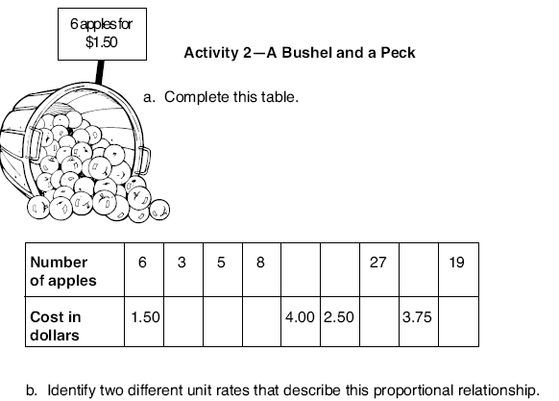

Mrs. Gonzalez is going to bake some homemade apple pies for the Thanksgiving holidays! She bought fresh apples this weekend for her tasty pies.

MCFD01003_0000[1]

* Identify the two different unit rates (actual values) that describe this relationship.

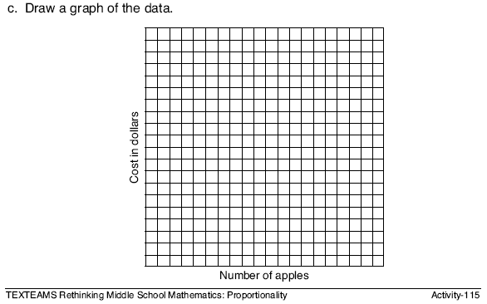

d. Extension

Use the graph to find each answer:

➀ cost of 32 apples

➁ # apples for $6.00

➂ # apples for $7.50

➃ cost of 18 apples

Use 2 for the x scale & $0.50 for the y scale.

Is this a proportion? \_\_\_\_\_\_\_\_

(Why or why not? Prove it.)

