1. The enrollment at Clifford JHS from 1997 through 2001 is shown below. Ray’s dad attended Clifford JHS in 1994.

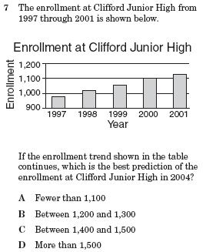

If the enrollment trend shown in the table was the same in the 1990’s, which is the best estimate of the enrollment at Clifford JHS in 1994?

A between 1200 and 1300

B between 900 and 1000

C between 800 and 900

D between 700 and 800

1. At Calallen MS, 200 students were asked to name a career they would like to pursue. The results are shown below.

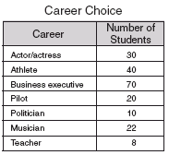

**(continued in next column)**

Which of the following statements is NOT supported by data the table?

A Less than 25% of the students would

like to pursue a career as an athlete.

B 10% of the students would like to be a

pilot.

C Pilot was a choice for twice as many

students as politician.

D 8% of the students want to be a

teacher.

1. The table shows the number of blue-plate specials sold at Granny’s Diner each day last week.

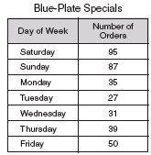

Which statement is supported by the given data?

A Half of the blue-plate specials were

ordered on Friday.

B More than twice as many blue-plate

specials were ordered on Sunday than

Friday.

C About 50% of the blue-plate specials

were ordered on Sat. and Sun.

D The fewest blue-plate specials were

ordered on Tuesday because it is not a

special night to celebrate.

1. The graph below shows the number of gallons of water used to produce a pound of various types of food.

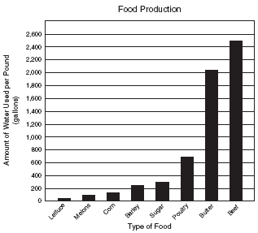

Which statement is NOT supported by the data?

A Corn takes about ½ as much water to

grow as barley does.

B 50 gallons of water is enough to

produce 1 pound of melons.

C It takes approximately triple the

amount of water to produce 1 lb of

butter as to produce 1 lb of poultry.

D It takes more water to produce 1 lb of

beef than all the other listed foods

combined.

1. The circle graph below shows the materials in U.S. landfills.



Which statement is supported by the graph?

A Metal materials are double the

quantity of rubber and leather

materials.

B More than  of the materials in

U.S. landfills is paper.

C Metal is  the materials in U.S.

landfills.

D Approximately of U.S. landfills

consist of “other” trash.

1. The data in the table shown below shows the number of lunch items sold at the CMS snack bar in one day.



Which statement is NOT supported by the data?

A The number of students who bought

hamburgers is less than 50% of the

number of students who bought a slice

of pizza.

B The number of students who bought

hamburgers is 40% of the number of

students who bought regular milk.

C Chocolate milk is approximately 50% of

the milk sold today.

D The number of nachos sold is

approximately  the number of food

items sold today.

1. Mr. Flores kept a record of the times one bus arrived at school. The table below shows the percent of time that the bus arrived on time or was late.

Which statement is NOT supported by this data?

A The bus was late more than it was on

time.

B The bus was late 5 minutes 1 second to

10 minutes late  of the time.

C The bus was often late because

students misbehaved in class.

D The bus was late by 10 minutes or less

half of the time.

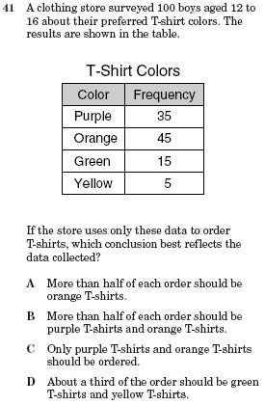

10



