1. Monthly high temperatures in Skidmore, Texas, for 2004 are listed in the following table. (There were colder days; this data shows the hottest days.)

*Monthly High Temperatures for Skidmore, TX, in 2004*

|  |  |
| --- | --- |
| Month  Number | High  Temperature |
| 1 | 76°F |
| 2 | 76°F |
| 3 | 78°F |
| 4 | 81°F |
| 5 | 90°F |
| 6 | 96°F |
| 7 | 104°F |
| 8 | 107°F |
| 9 | 98°F |
| 10 | 91°F |
| 11 | 86°F |
| 12 | 83°F |

MCj04040030000%5b1%5d

|  |
| --- |
| Organized Data |
|  |
|  |
|  |
|  |
|  |
|  |
|  |
|  |
|  |
|  |
|  |
|  |

* You will answer several questions for problem #1 (using this data).
* What is the range of this data? _____________

✌ Circle one choice: True or False. *“There is NO MODE for this data.”*

* + If the answer is TRUE, explain WHY; if it is FALSE, then give

the mode and tell me WHY that value is the mode.

🖏 Circle one choice: True or False. *“The MEDIAN for this data is 100.”*

* + If the answer is TRUE, explain WHY; if it is FALSE, then find the

correct median – with PROOF in terms of work.

❓PREDICT (make a reasonable guess by looking at the data & THINKING)

* Do you think that the MEAN will be closer to 80, 90, or 100 ?
* WHY did you pick this number????
* Circle your prediction, then check your guess.

1. Cindy’s mom asked her about her grades in her language arts class. Cindy looked in her notebook and copied the following assignment grades on a piece of notebook paper. 87 100 95 0 88

Cindy told her mom that she had an “A” in language arts class. What type

of reasoning helped Cindy make this conclusion? [Justify your answer!]

* 1. Cindy calculated her median grade to be a 95.
  2. Cindy calculated her mode grade to be 95.
  3. Cindy calculated her mean grade to be a 92.5.
  4. Cindy calculated her range to be a 100.

1. Adam and Michael researched and recorded the annual rainfall for the King Ranch area for the last 7 years. This is an important statistic in our agricultural community, especially for the farmers. The amounts are listed in the table below.

*Weekly Rainfall*

|  |  |  |  |  |  |  |  |
| --- | --- | --- | --- | --- | --- | --- | --- |
| Year | 1998 | 1999 | 2000 | 2001 | 2002 | 2003 | 2004 |
| Amount of rain (in inches) | 18.2 | 21.7 | 16.4 | 22.1 | 23 | 20.3 | 19.6 |

🏳 Which conclusion best reflects the data collected? [PROVE IT! ]

MCj03339380000[1]A. It always rains more in an odd-numbered year than an

even-numbered year.

B. The median amount of rain is 22.1 inches.

C. The mode amount of rain is 23 inches.

D. The mean amount of rain is about 20 inches.

…

1. Mr. Taylor’s 7th grades in scores on the first benchmark test are listed in the stem-and-leaf plot below.

PROOF = written explanation or math work

**PROVE or DISPROVE EACH answer choice!**

MCj03326800000[1] Stem Leaf

10 0 2

9 2 3 3 3 7

8 4 4 6 8

7 1 2 5 8

6 0 2 7 *8* l *4 = 84*

Which of the following statements is supported by the data?

A. Every student passed the benchmark test.

B. The number of students that made an A is twice the number that made a

B on the benchmark test.

C. The median benchmark test grade is an 85.

D. 20% of the class failed the benchmark.

1. Matt’s summer basketball team needs to raise money to travel to their All-Star Tournament in Dallas, TX, in August. They have had several fundraisers, including a soda sale. On Friday the team turned in their soda orders and money; the orders are listed in the table below.

MCj03402420000[1] *Matt’s Basketball Team’s Soda Sales*

|  |  |
| --- | --- |
| *Soda* | *# of cases sold* |
| Diet Coke | 61 |
| Sprite | 40 |
| Dr. Pepper | 82 |
| Coke | 57 |
| Root Beer | 28 |
| Big Red | 11 |

PROOF = written explanation or math work

**PROVE or DISPROVE EACH answer choice!**

Which statement is NOT supported by the data?

A. Approximately 10% of the soda sales are for root beer.

B. Sprite makes up approximate one quarter of the sales.

C. There were almost 3 times as many Dr. Pepper cases sold as

root beer cases sold.

D. Dr. Pepper and Diet Coke make up about ½ of the soda sales.

1. Jamal’s favorite basketball star is Ben Wallace, the 6’9” Denver Piston

center. Although Ben has averaged nearly 10 points per game the last two seasons, his true strength lies in his defensive skills. In 2004-05 Wallace won the NBA Defensive Player of the Year for the 3rd time in 4 seasons; furthermore, he is only 1 of 4 players in NBA history to average at least 12 rebounds and 2 blocks per game for 5 straight seasons.

MCj03982830000[1] ~~~~~~~~~~~~~~~~~~~~~~~~~~~~~~~~~~~~~~~~~~~~~~~~~~~~~~~~~~~~

j0199283 “Food for Thought”: What does an “average of 12 rebounds” per

game mean? Did Ben get 12 rebounds in every

game? Could he ever have gotten more? Less?

~~~~~~~~~~~~~~~~~~~~~~~~~~~~~~~~~~~~~~~~~~~~~~~~~~~~~~~~~~~~

This problem is continued on the next page. . .

Eighth grader Jamal is focusing on his defensive play; he has significantly

improved since the beginning of the season. The table below summarizes

Jamal’s data up to this point this season.

|  |  |  |  |  |  |  |  |  |  |  |
| --- | --- | --- | --- | --- | --- | --- | --- | --- | --- | --- |
| Game | 1 | 2 | 3 | 4 | 5 | 6 | 7 | 8 | 9 | 10 |
| Rebounds | 2 | 3 | 7 | 8 | 5 | 10 | 8 | 11 | 13 | 10 |

Based on the data provided, which conclusion is most reasonable?

A. Jamal’s average rebounds will be close to Ben’s record-setting average.

B. Jamal’s season rebound average will probably be less than 5.

C. Jamal’s coach can probably rely on Jamal for at least 8 rebounds in the

next game.

D. Jamal will break Ben Wallace’s personal record soon.

1. The graph below shows overall top medal winners for the Winter Olympics.

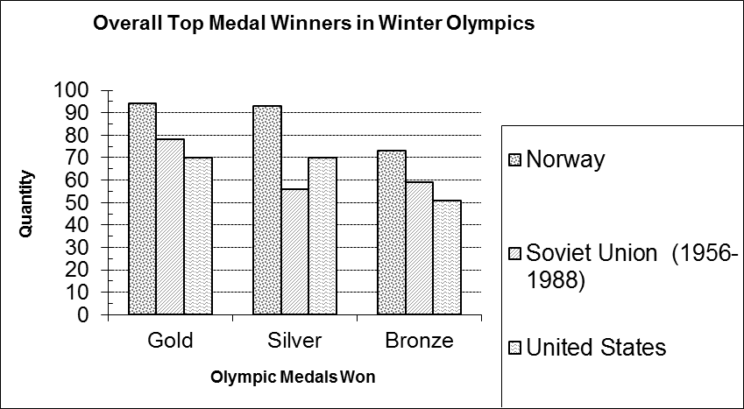

🏳Which statement is supported by the data?

[ PROVE or DISPROVE EACH STATEMENT!!!]

A. Norway won more medals than the Soviet Union and United States

combined.

B. The United States only won about ½ as many silver medals as Norway.

C. Approximately 25% of the United States’ medals were bronze medals.

D. Approximately 50% of Norway’s medals were silver medals.