11



10



9 Find x.



8 (63.2)(2.14)

7 ${(1+3)}^{3} ÷ 2 ∙ 3$

6 

5 

4 Keep going until you get a zero remainder.

6.31  0.4

3 Leave the remainder as a fraction. 37,582  11

2 

1 

REVIEW

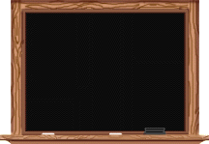

7-4-1



12 

~~~~~~~~~~~~~~~~~~~~~~~



13 

14 8% of $46 = __________

~~~~~~~~~~~~~~~~~~~~~~~

$\frac{1}{8} of \$104= _____________$

15 4.93 + 205 + 32.4

16 400 – 9.76

17

–3 + (–4) = _________

~~~~~~~~~~~~~~~~~~~~~~

5 + (–2) = _________

18 –6 – 4

19 5 – 8

20

(8)(–7) = ________

~~~~~~~~~~~~~~~~~~~~~~~

 = ________